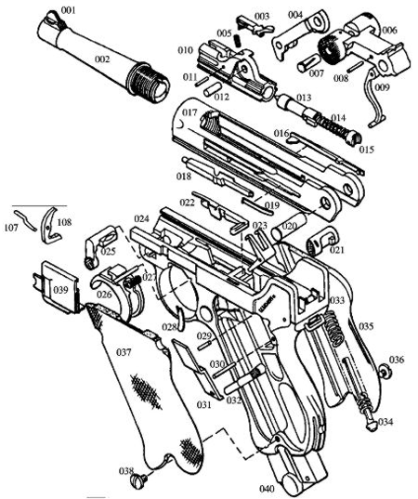
001 FRONT SIGHT
002 BARREL
003 EXTRACTOR
004 CENTER TOGGLE LINK
005 EXTRACTOR SPRING
006 REAR TOGGLE LINK
007 CENTER TOGGLE PIN
008 COUPLING LINK PIN
009 COUPLING LINK
010 BREECH BLOCK.
011 EXTRACTOR PIN
012 BREECH BLOCK PIN
013 FIRING PIN
014 FIRING PIN SPRING
015 FIRING PIN SPRING RET.
016 EJECTOR
017 BARREL EXTENSION
018 SEAR BAR
019 SEAR BAR SPRING
020 REAR TOGGLE AXLE
021 MAGAZINE CATCH
022 HOLD-OPEN LATCH W/SPR.
023 RECOIL LEVER
024 FRAME
025 LOCKING BOLT
026 TRIGGER
027 TRIGGER SPRING
028 MAGAZINE CATCH SPRING
029 SAFETY LEVER PIN
030 RECOIL LEVER PIN
031 SAFETY BAR
032 SAFETY LEVER
033 MAINSPRING
034 MAINSPRING GUIDE
035 GRIP PANEL WALNUT
036 GRIP SCREW
037 GRIP PANEL WALNET
038 GRIP SCREW
039 TRIGGER SIDEPLATE
040 MAGAZINE
107 TRIGGER LEVER PIN
108 TRIGGER LEVER

